Chapter 4
1. Dice Throw Problem – Dynamic Programming

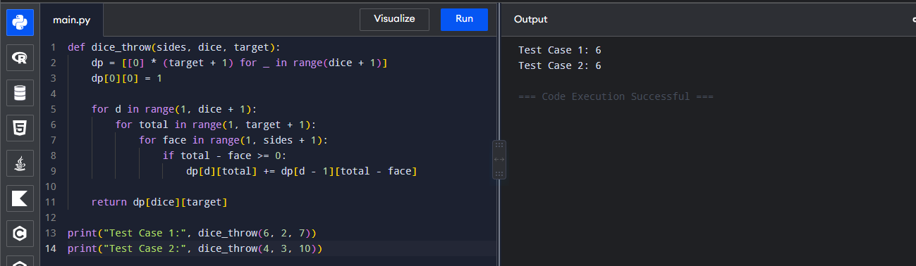
2. Assembly Line Scheduling
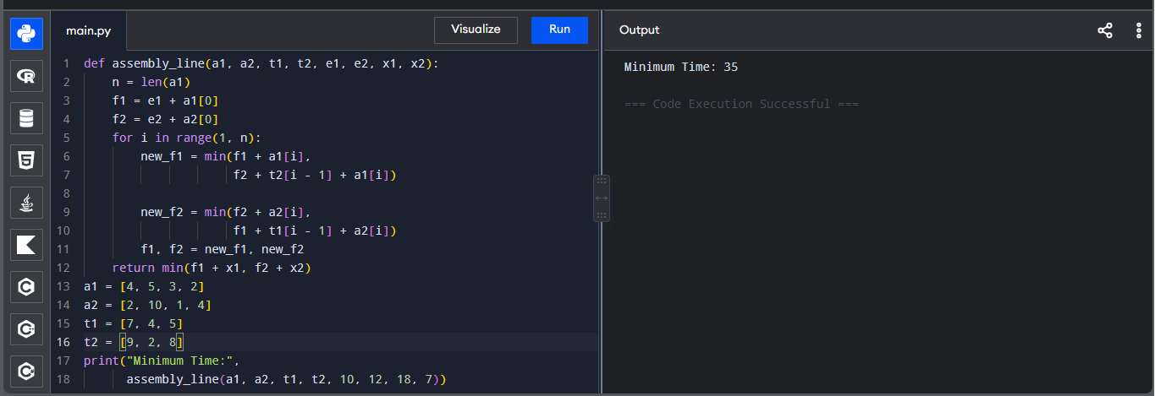
3. Three Assembly Lines
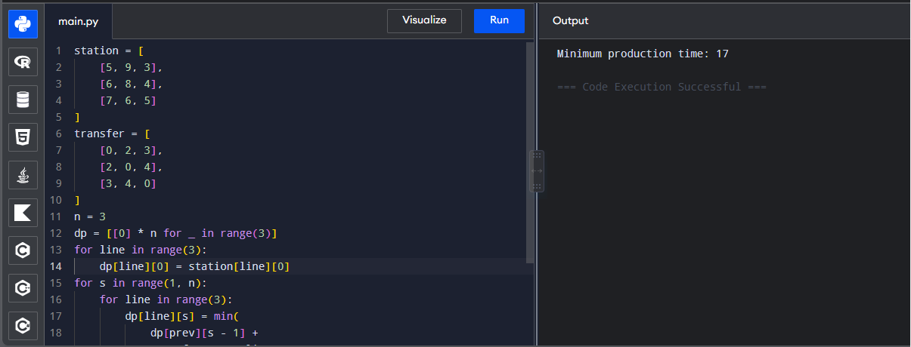

4. Minimum TSP Path Using Matrix
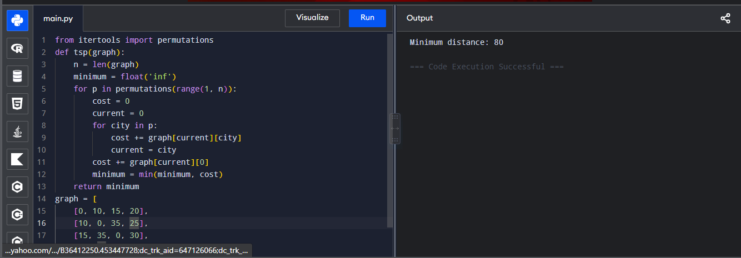
5. TSP with Five Cities
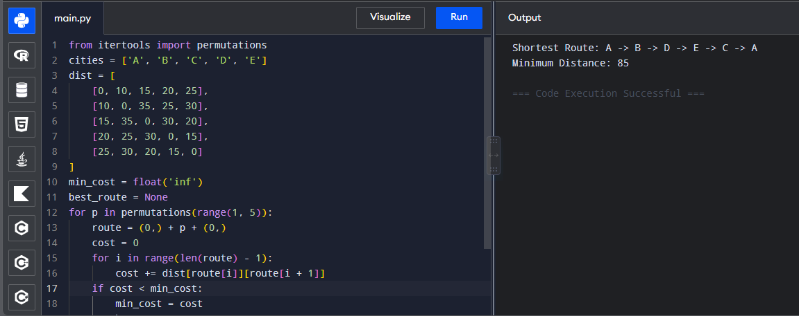
6. Longest Palindromic Substring
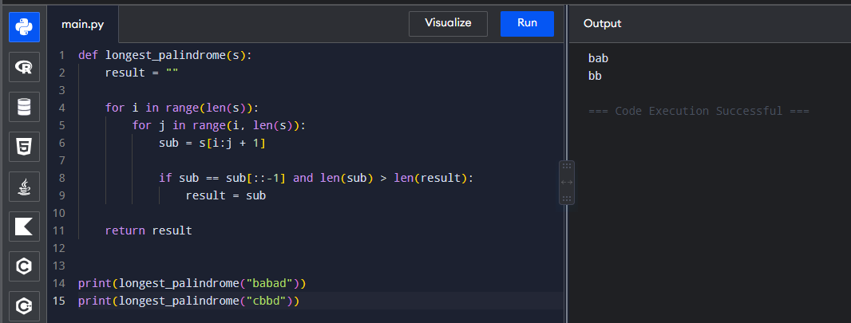

7. Longest Substring Without Repeating Characters
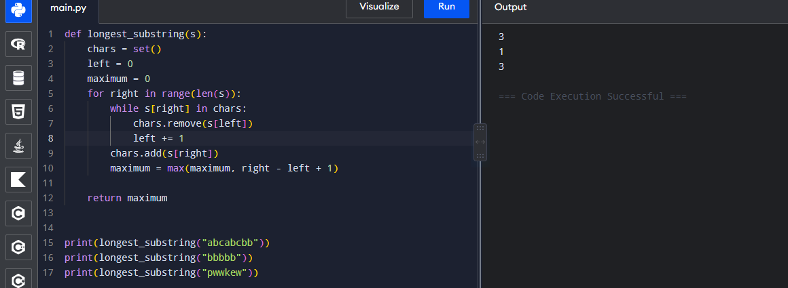
8. Word Break Problem
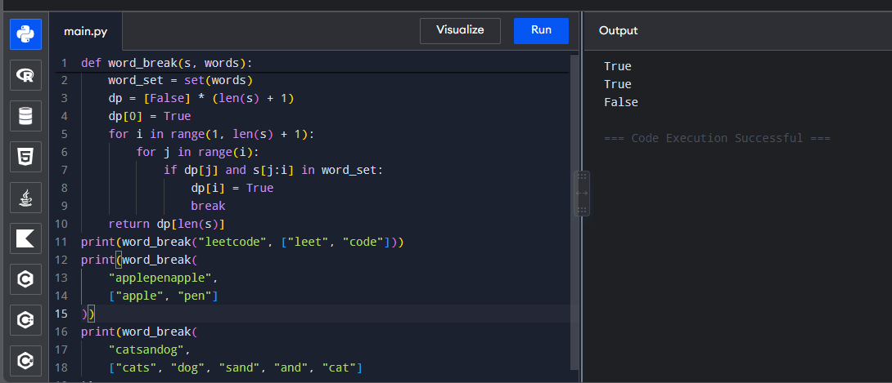
9. String Segmentation Using Dictionary
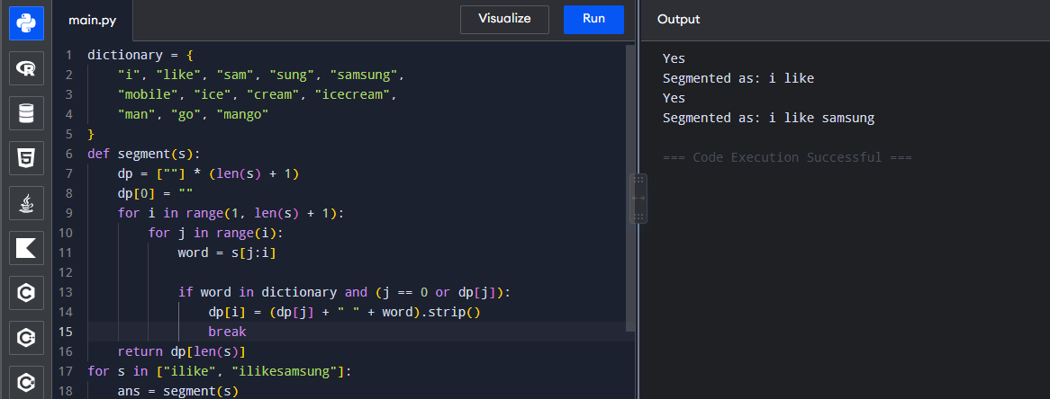

10. Text Justification
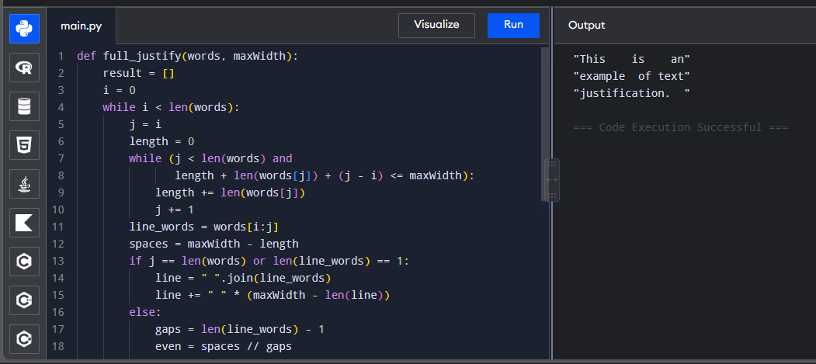
11. Prefix and Suffix Word Filter
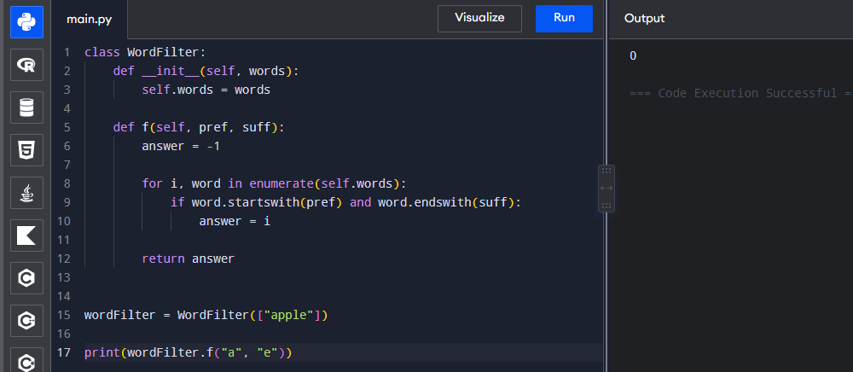
12. Floyd-Warshall Algorithm
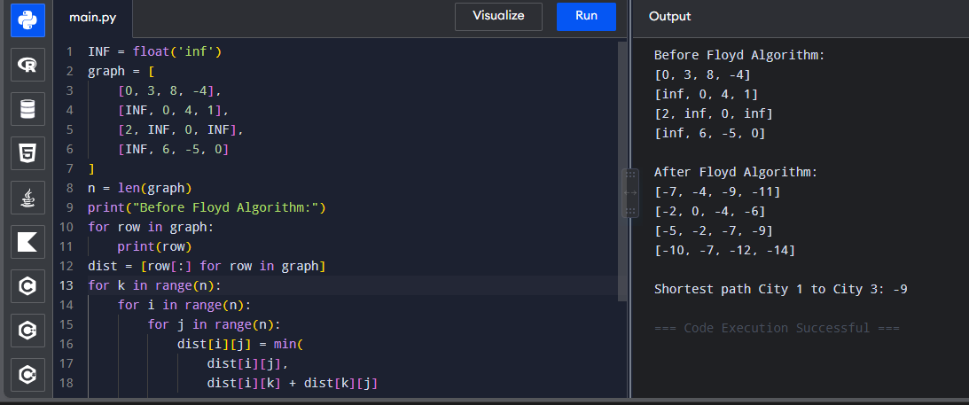
13. Floyd Algorithm – Router Link Failure
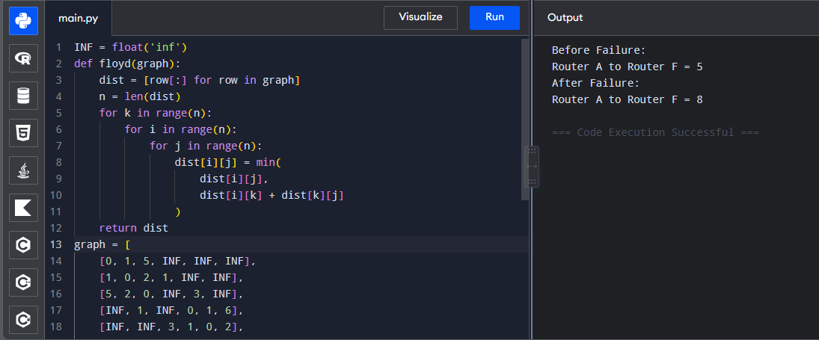
14. Floyd Algorithm – Find City / Shortest Path
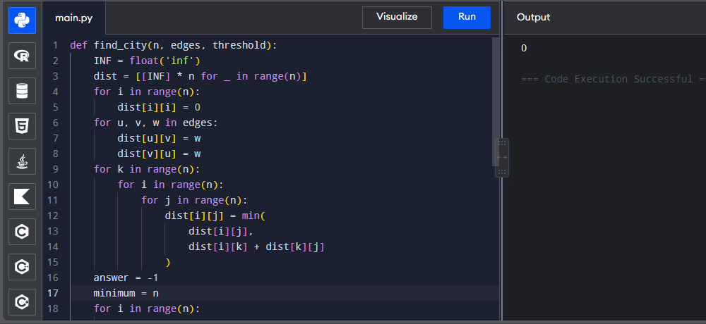
15. Optimal Binary Search Tree
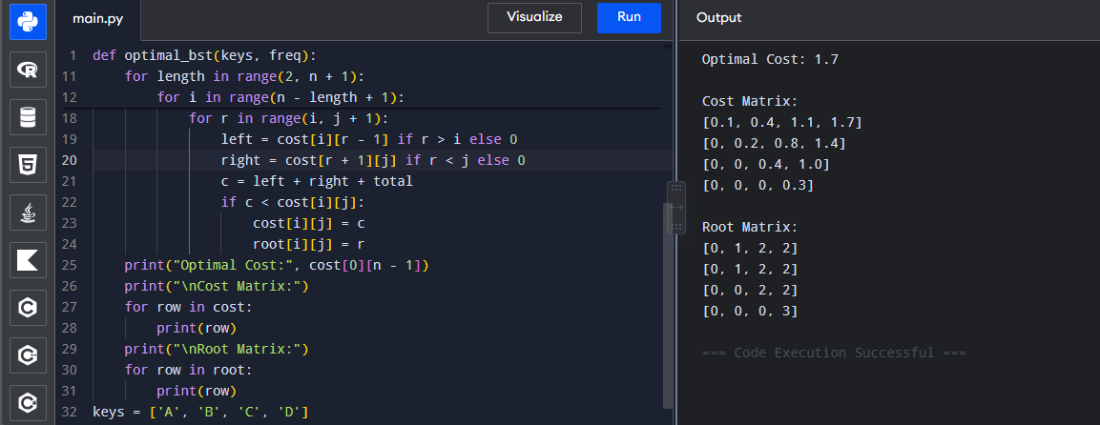

16. OBST with Integer Frequencies
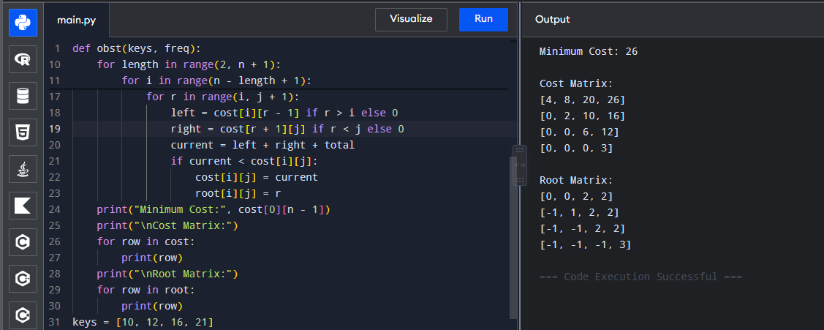
17. Cat and Mouse Game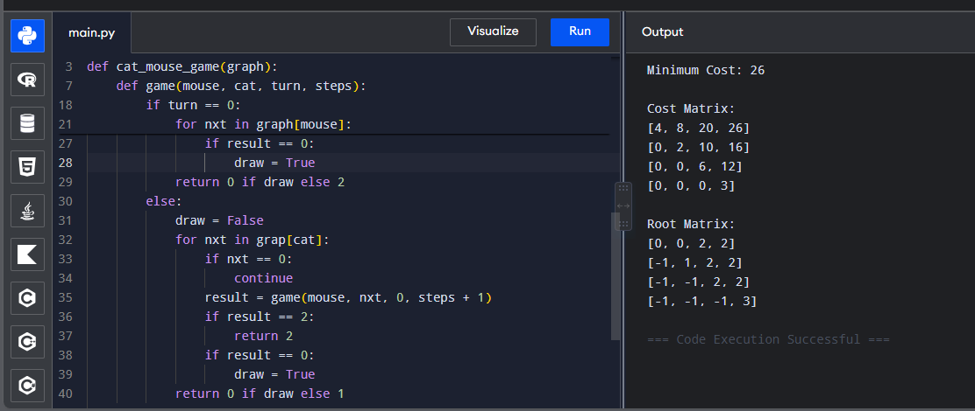
18. Maximum Probability Path
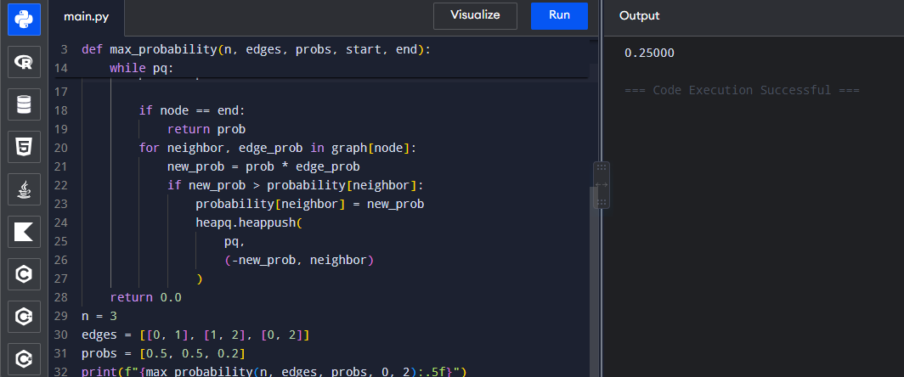

19. Unique Paths in Grid
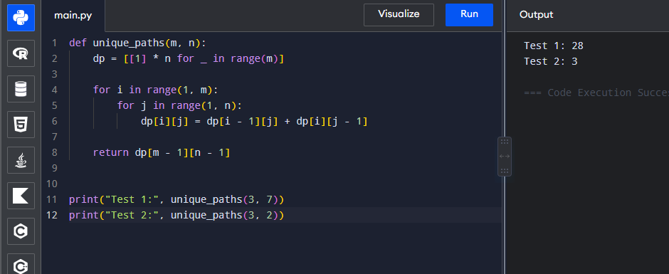
20. Number of Good Pairs
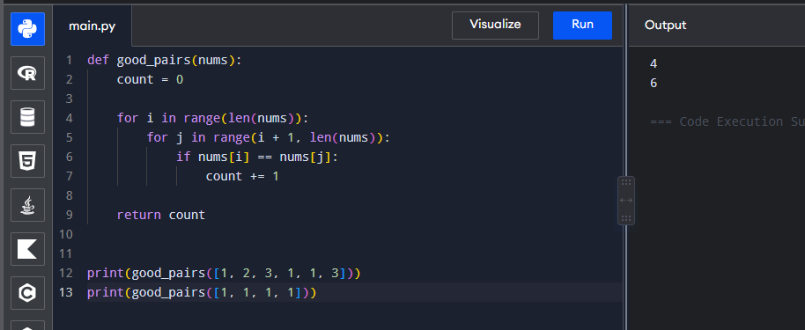
21. City With Smallest Number of Neighbors
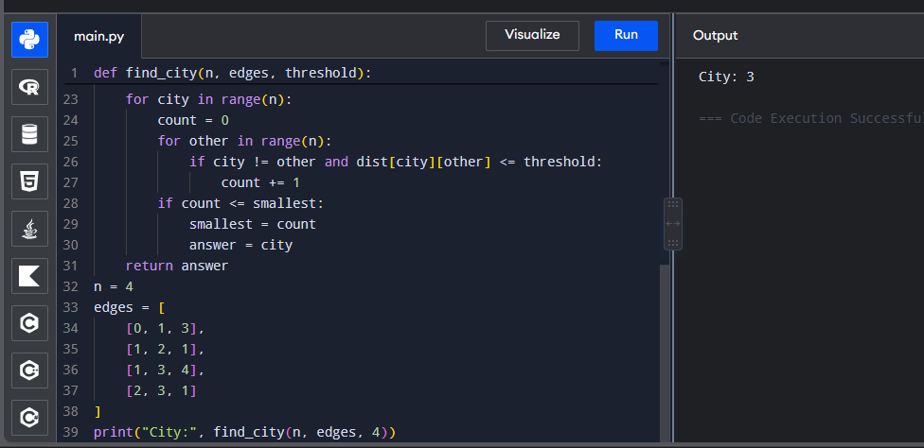
22. Network Delay Time
